**Copying an Image from a USB flash drive to a Computer**

1. Boot from the Clonezilla Live USB flash drive (On an EeeBox, press and hold F8 to enter the Boot Menu)
2. Choose **Other modes of Clonezilla live**
3. Choose **Clonezilla live (To RAM. Boot media can be removed later)**. This allows you to use the USB stick as a boot device as well as store the image.
4. Allow Clonezilla to copy to RAM. When you see the screen prompting for the language, *remove the USB flash drive before choosing a language*.
5. Choose the language settings for Clonezilla, English
6. Under Configure console-data, choose **Don't touch keymap**
7. Choose **Start_Clonezilla Start Clonezilla**

[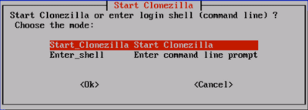](http://wiki.inveneo.org/index.php/Image:ClonezillaCD-02.gif)

1. Choose **device-image disk/partition to/from image**

[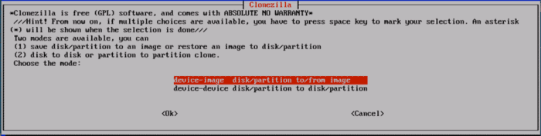](http://wiki.inveneo.org/index.php/Image:ClonezillaCD-03.gif)

1. On the Mount Clonezilla Image Directory screen, Clonezilla needs to know where to copy the image from. Clonezilla can copy the image to another computer on a network. However, we are trying to copy the image from a USB flash drive, so select **local_dev Use local device (Ex: hard drive, USB drive)**

[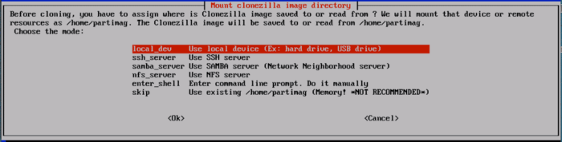](http://wiki.inveneo.org/index.php/Image:ClonezillaCD-04.gif)

1. On the Mount Clonezilla Image Directory screen, Clonezilla needs to know where the image is located. You are trying to copy the image from the USB flash drive so *before you press any keys*:
   * Insert the USB flash drive
   * Wait 10 seconds, or until you see sdb:sdb1 scroll by on the screen (depending on how many drives are in the computer, this could be sdc:sdc1 or sdd:sdd1)
   * Press **Enter**
2. Clonezilla needs to know where the USB Flash drive is located. Typically, Clonezilla will display all the drives it finds, including the drives of the computer. The computer's drive is usually listed as sda1 or hda1. Most of the time, the last option listed is the USB flash drive, usually listed as sdb1, if the computer you are cloning only has one hard drive. Looking at the hard drive size can help determine which drive is the computer's and which drive is the external hard drive's. Select the USB flash drive.

[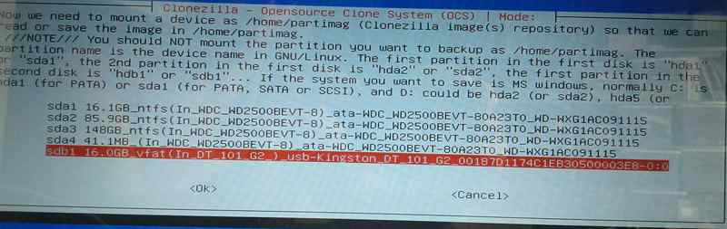](http://wiki.inveneo.org/index.php/Image:ChooseThumbDrive.jpg)

1. Clonezilla needs to know where on the external hard drive to find the image. Typically the image will be in the /Images directory so choose **/Images**. If the image is not found in step 17, try the top level directory **/ Top_directory_in_the_local_device**.

[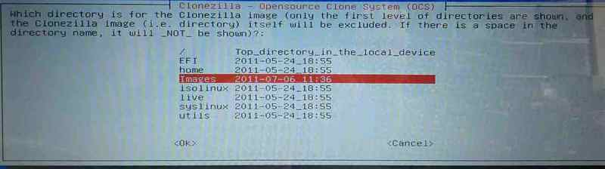](http://wiki.inveneo.org/index.php/Image:ChooseImageDirectory.jpg)

1. Press **Enter** to continue
2. Choose **Expert Mode**
3. Clonezilla is asking whether you want to create an image of the computer or put an existing image on the computer. In this case, Clonezilla will create an image of the computer and put that image on an external hard drive. Choose **restoredisk restore_an_image_to_local_disk**

[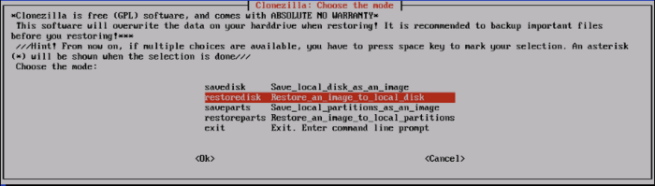](http://wiki.inveneo.org/index.php/Image:ClonezillaCD-15.gif)

1. Press **Enter** to continue
2. Clonezilla will display a list of all the images it sees on the USB Drive. Choose the appropriate image.

[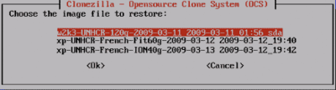](http://wiki.inveneo.org/index.php/Image:ClonezillaCD-16.gif)

1. Select which hard drive to put the image on. If the computer only has one hard drive, only one choice will be listed.
2. Tell Clonezilla the options/parameters for copying the image on the hard drive. Select **-g auto**, **e1 auto**, **e2**, **-nogui** and **j2**. [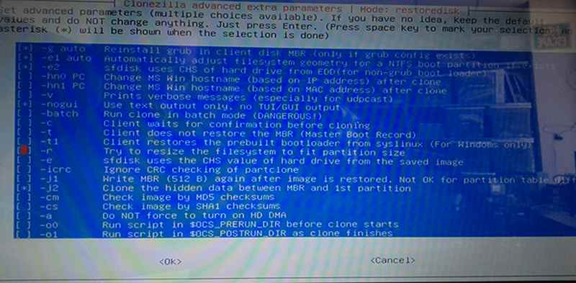](http://wiki.inveneo.org/index.php/Image:CZImagingParameters.jpg)
3. Tell clonezilla additional options for cloning. Choose the blank option, labeled **Use the partition table from image**

[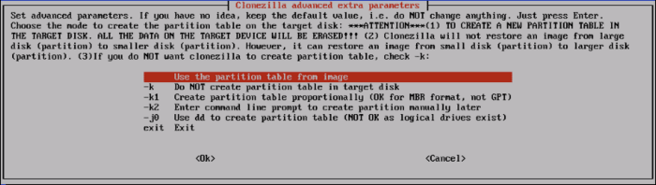](http://wiki.inveneo.org/index.php/Image:ClonezillaCD-19.gif)

1. After cloning, tell clonezilla to poweroff, **-p poweroff**
2. Press **Enter**
3. Let me ask you again, Are you sure you want to continue?? **y** and press **Enter**
4. When the imaging process is finished, the computer will poweroff. When you start the computer again it will go through the Windows Setup process. The computer may reboot once during the setup process. Continue through the setup wizard. At the end of the wizard you are presented with the Inveneo CKC desktop.